Creating 3D Printed Movable Tactile Pictures for Children with Visual Impairments

# ABSTRACT

## Author Keywords

Tactile Pictures; 3D Printing; Fabrication

## ACM Classification Keywords

H.5.m. Information interfaces and presentation

# INTRODUCTION

Movable pictures, such as lift-the-flap books are popular in children’s books. They are beneficial for the development of emergent literacy among young children. Figure 1.a. is an example of a movable picture from the book *What’s the opposite?,* a book that teaches preschoolers opposite spatial concepts such as up/down and lost/found. Pictures in this book are movable in a sense that the paper these pictures are printed on has non-stationary parts children can move with their hands, such as lifting, pulling, and spinning. These movements then cause the visual content of the pictures to change. For example, a child can lift a flap (comforter) and another object (toy), previously hidden underneath the flap, appears. Tangible interactions with movable pictures like this are mostly paper-based with no electronics involved. It is through such interactions children are able to connect kinetic experiences (flipping) with visual experiences (to appears) and learn novel concepts.

For those who visually impaired (VI), however, the benefits of movable pictures are limited. VI children can still obtain the kinetic experiences as they flip, pull, and spin. But they are unable to relate these kinetic experiences to corresponding visual experiences. They are unable to see that a flap is a part of a comforter, or that there is a toy underneath. Without the visual experiences made accessible to them, the kinetic experiences they got are mostly in vain with little or no educational benefit.

3D printing has been shown to be a promising method to make pictures in children’s books accessible to VI children [CITE]. A picture can be 3D modeled as a tactile picture that can be touched, felt, and understood by a blind child. Figure 1.b gives examples of 3D-printed tactile pictures made for *Goodnight Moon,* and *Harold and Purple Crayon*, two children’s book classics.

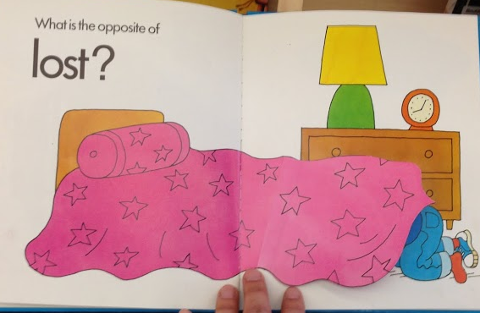 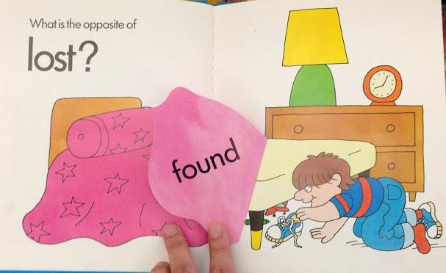

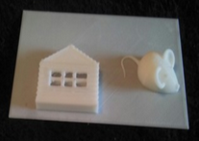 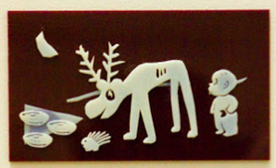

**Figure 1. Movable pictures promote emergent literacy by connecting kinetic experiences (e.g., lifting a comforter) with visual experiences (e.g., discovering a toy) (top). But this connection is broken for blind children because the printed text inaccessible. 3D printing makes visual experiences in children’s books accessible to blind children (bottom), but only for static pictures, not for movable pictures.**

However, 3D printing so far has been limited to the creation of static images in children’s books. Techniques previously developed for making static tactile pictures [CITE] may not apply to the making of movable tactile pictures. Movable tactile pictures pose several new challenges. In this paper, we identified three to address:

1. **Moving Primitives:** How can we create tactile models that can be flipped, spin, and pulled by children?
2. **Visual Effects:** How can we make the visual effects accessible to VI children as they flip, spin, and pull?
3. **Synthesis:**  To what extent new tactile pictures can be synthesized automatically from a given set of moving primitives and visual effects chosen by a designer?

# RELATED WORK

**3D Printed Tactile Graphics for Emergent Literacy**

3D printing has risen up a promising method for helping parents to replicate tactile books. [Kim] Also, 3D printing has been used for tactile visualization for visually limited people. [Craig] 3D printing afforded ease in replicability, and customizability a key challenge in creating tactile graphics [Lipson, H], while helping children with visual impairments develop emergent literacy. [Abigale]

**Elements of Good Tactile Book**

There are resources and guidelines [Philippe] [Suzette] available to parents interested in creating tactile graphics, that introduces elements consist of good tactile pictures. These guidelines emphasize the importance of interaction and mobility. The majority of tactile books currently created by artists have mobility features that lead children’s interactions. Figure below shows how interaction on mobility is incorporated current tactile book. A bunny is moving through page by page, from the middle of the room to the bed to say goodnight to everything. If tangible interaction provides non-visual access to the pictures [McGookin], how can we incorporate interaction features into 3D printed books?

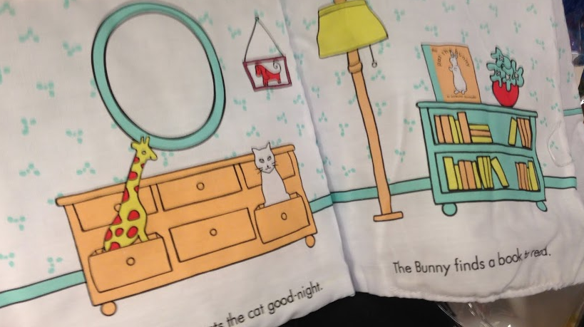 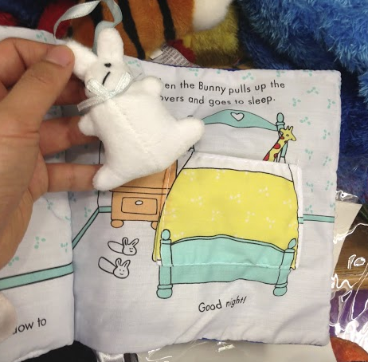

Figure XX. A bunny bookmark is place in the middle of a room, and finally put inside the pocket of comforter at the end of a story.

**Empowering Tangibles for Learning**

Tangible interactions books encouraged sighted kids’ interests into the book content. [Hengeveld] Since children’s attention is the key to develop emergent literacy from children book [Bus], having their awareness to the book amalgamation of various tangible technic with 3D printing will take a huge role to bring active participation. [Marshall] [Fontijin] Interaction captivates disabled children in inclusive learning process forming early narratives developments, [Franca][Budd] tangible interaction seemed to be the essential components of 3D printed tactile book for blind children.

**Reuse of Pre-designed 3D Models**

The majority of parents and teachers of blind children do not have firm idea about 3D printing, event though this emergent technology helps them to create unique educational materials for their blind children. [Abigale] Online 3D design warehouses [Thingiverse][sketchup] exposed a chance for users to print a well-made 3D design without creativeness. For example, without complicated and refined skillset to design a fine giraffe, even blind children can print a giraffe via voice command, touch, and get idea how it looks like. [yahoo japan] 3D warehouses enabled reuse of 3D tactile models for novice designers, but if parents need to customize a premade model by integrating mobility to create tactile book, how the technology support their needs?

**formative studIES**

We conducted two formative studies to understand the problem space. Our main goal was to find out how a human designer, who has no expertise on 3D software would approach to the task of 3D modeling and printing movable tactile pictures. Informed by the findings we aimed to create an interactive system to support the design process as well as develop the underlying technical and algorithmic components to enable such system. How available are them? Why is it difficult?

**Children Book Research**

|  |  |  |  |
| --- | --- | --- | --- |
| Hinge | Pulley | Spinner | Swing |
| Macintosh HD:Users:qubick:Desktop:Screen Shot 2014-09-02 at 9.39.30 PM.png | Macintosh HD:Users:qubick:Desktop:Screen Shot 2014-09-02 at 9.39.51 PM.png | Macintosh HD:Users:qubick:Desktop:Screen Shot 2014-09-02 at 9.39.39 PM.png | Macintosh HD:Users:qubick:Desktop:Screen Shot 2014-09-02 at 9.40.00 PM.png |

Figure XX. Four types of Primitives

Our first research challenge was to figure out how to model moving primitives. The goal was to derive a common vocabulary of moving primitives that can be applied to as many movable pictures in today’s children’s books as possible. We surveyed 12 children books with movable pictures and identified four most common classes of movements: hinges, pulleys, spinners, and swings. We went through a number of design iterations and arrived at a vocabulary of ready-to-print moving primitives that can be added to tactile pictures to make them movable. The figure above shows our final 3D models of moving primitives.

## Initial Observation with Wood Prototype

|  |  |  |
| --- | --- | --- |
| Macintosh HD:Users:qubick:Library:Application Support:iLifeAssetManagement:assets:sub:01fa5110ec21e11663af72c7972393e98651e92fcb:IMG_6498.JPG | Macintosh HD:Users:qubick:Library:Application Support:iLifeAssetManagement:assets:sub:013a88cd3e50cba3abb8af5b41a48be9e86559b2a4:IMG_6504.JPG | Macintosh HD:Users:qubick:Library:Application Support:iLifeAssetManagement:assets:sub:0124d9f8fe299385fefaaf4d5bf816b45a6bf20799:IMG_6499.JPG |
| Macintosh HD:Users:qubick:Library:Application Support:iLifeAssetManagement:assets:sub:0175bfc57922084010f3c9e2515111be9fec418751:IMG_6500.JPG | Macintosh HD:Users:qubick:Library:Application Support:iLifeAssetManagement:assets:sub:0126c6476bcd4167f5ca2042a437f43f12810b1d4c:IMG_6508.JPG | Macintosh HD:Users:qubick:Library:Application Support:iLifeAssetManagement:assets:sub:0173dfa8d022edc31278415f376bc8c9ed258aeb10:IMG_6501.JPG |

Figure XX. Wood Prototypes of moving parts

In order to prove the usability and adaptability of moving primitives, we created wooden laser cut prototypes of common movable part. The figure above shows our example of moving parts. The rocket uncovered by cloud (a) is example of the hinge, as well as the moon behind the sail (b) of a boat. The biking roller coaster (c) is an example of swing, while the giant wheel is an application of spinner (d). The spinner is easily applied to any kinds of wheel, such as car tire from (f), which is combined with another hinge for car door that uncover a chair and handle inside the car. To present a caterpillar that eat through the apple, pulley is a good trigger to enable children moves a part of picture.

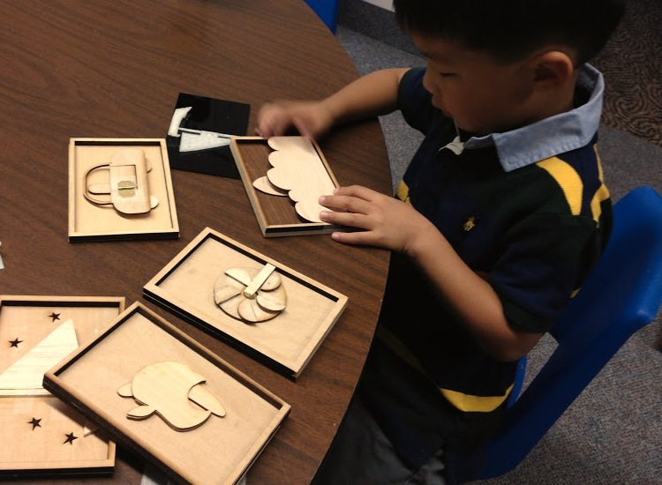

Figure XX. A sighted kid is playing with movable picture

We observed sighted kids to play with this movable parts, to see (1) how much they are more involved in interaction with pictures, (2) how much they intuitively interact with moving parts, and (3) in which way they play with moving tactile pictures. Naturally, sighted kids opened the door of the car, waved the sail of a boat, touches behind the flag, spin the wheel, push and pull the caterpillar. One kid made his own narrative with rocket while playing, saying “Ready, 5, 4, 3, 2, 1, bluster!”. And one kid asked what is the behind the apple. They dealt with the tactile pictures as a toy, with a lot of curiosities, by fidgeting any movable part of each picture despite any context is given. We found some ground findings from the initial observation, moving part more attracts children’s attention and interest, prompting their intellecture curiosities.

**Design Workshop**

In our first formative study, we chose to focus on a population with high motivation but without any assumption about their 3D modeling skills. We conducted a design workshop participated by 18 high-school students through two design workshop, who expressed interests in 3D printing. Students were given the task of making a 3D model based on a movable picture in a children’s book. They were also given the freedom to choose their favorite book to model. Instead of using 3D modeling software, students were given a bucket load of Lego bricks to create physical models. Below figure shows some tactile movable pictures created by these students. Gorilla (a) was feature by moving arms back and forth fabricated by 360 degrees rolling Lego piece. Waiving butterfly’s wing (b) were resented with a tape which is flexible, and 360 degrees rolling Lego piece too. The cage holds a giraffe (c) were interpolated by hinge piece of LEGO block, and stepping joints of flamingo leg (d) were stated with play-doh joint and wood sticks.

|  |  |  |  |
| --- | --- | --- | --- |
| Macintosh HD:Users:qubick:Desktop:Screen Shot 2014-09-19 at 5.31.03 PM.png | Macintosh HD:Users:qubick:Desktop:Screen Shot 2014-09-19 at 5.50.01 PM.png | Macintosh HD:Users:qubick:Desktop:Screen Shot 2014-09-19 at 5.30.42 PM.png | Macintosh HD:Users:qubick:Desktop:Screen Shot 2014-09-19 at 5.49.17 PM.png |

Figure XX. Four movable tactile pictures designed by students. (a)Gorilla with moving arm, (b) waiving butterfly’s wing, flapping cage with giraffe inside, and (d) kneeling flamingo’s leg

Students were excited to the fact that they can make part of the 2D picture movable, despite all of books they chosen were not pop-up books. They imagined how moving primitives can be adapted to the pictures, based upon their experiences with real life objects, such as flying wing, stepping joint of leg, etc. Once a set of moving primitives are given, designers think about the use of movable parts to add interaction with their real experiences upon object.

# MOVABLE TACILTE PICTURE

The goal of this research is to enable the creation of tactile picture books a VI child can move! Here we present a suite of reusable 3D components we developed for the purpose of creating movable tactile pictures.

## Design Goals

During our formative studies, we identified a number of design requirements that have influenced many of our design choices as we were developing these 3D components.

* **Easy to interact:** This is the goal of the project, making tactile pictures movable for VI children.
* **Easy to print:** A model can look nice in a design environment and may not be easy to print with a commodity 3D printer. The model may have invalid geometry. It may require support material. On the one hand, it is necessary to break a model into parts that can be separately printed.
* **Easy to assemble:** When pieces are printed separately, the process of assembling them together must be easy.
* **Easy to customize:** It should be possible to customize various aspects of a component.
* **Easy to reuse:** These parts should be easy for people to reuse to make new tactile pictures.
* **Hard to break:** Young children are often *destructive*. Parts should provide adequate sturdiness to allow repeated uses.

There are also factors worth considering but not as pressing as those above: Are models mass producible? How can we incorporate multiple materials? How can we add high-contrast colors?

## Page

We model a book as a series of tile-like pages. Each page is composed of three types of components: canvases, tactile objects, and connectors. A canvas acts as a container of one or more tactile objects. Each tactile object is physically joined to a canvas by a connector. The most basic page has one canvas, one object, and a connector joining the two. A more complex page may have multiple canvases with different sizes and at different heights, all joined together.

## Canvas

We model a canvas as a flat rectangular solid. The attributes are sizes and positions. A canvas can have a frame. A canvas can have rounded corners.

## Tactile Objects

These are contents to be added to a canvas. We consider three kinds of tactile objects.

### Raise Lines

It is the most common form of tactile graphics. The process to 3D model raise lines is simple. We draw some lines. And then we extrude. We can smooth the edges.

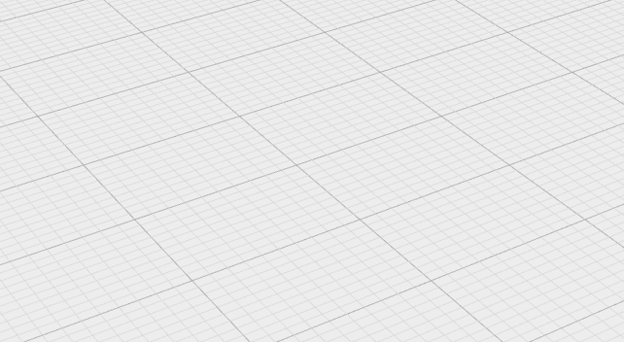

### Relief

It is the most common form of tactile graphics seen in today's children's books for VI children. A tactile artist would create a master using clay. Then a thermo printer is used to press paper against the mold to make relief. Two methods can be used to bring relief patterns into 3D. One way to make one is through a 3D scanner. Another way is to use computer vision to extract salient features and map them to different heights. Then a terrain map kind of structure can be generated.

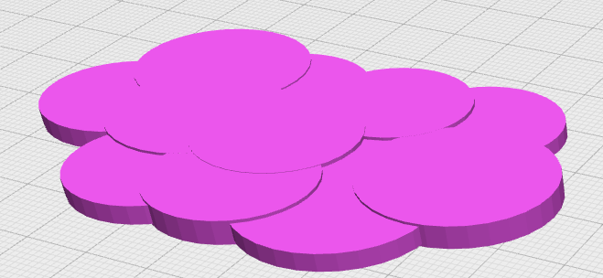

### 3D “Things”

Many pre-made, ready-to-print objects have now been made available on sharing sites such as Thingiverse. It is possible to download a suitable model and use it in a tactile book.

We use two methods to incorporate things into a model. The first method is to choose a prominent side or viewing perspective, for example, the profile view of a cow or a top view of a bucket. This method is preferred when the story needs to emphasize a particular attribute of an object, for instance, how tall a cow is. Given an imported model, the process of obtaining a perspective 3D model proceeds as follows. First, we define a plane cutting through the imported object. Next, we define a large cube on one side of the plane. Finally, we take the difference between the object and the cube to obtain a perspective representation of an object.

The second method is to represent an object as the whole, for example, the entire cow or the entire bucket. This method is preferred when the story emphasizes free exploration of an object from multiple viewing perspectives, for instance, what does a cow look like? Given an imported object, we may keep it as is, scale it to convey the relatively sizes with another object, or flatten it a bit to reduce the page's overall thickness.

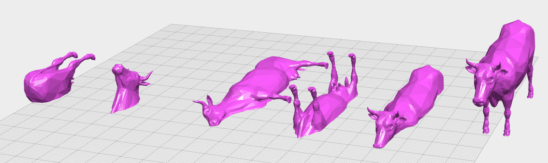

## Connectors

For raised lines and relief patterns, connecting to a flat canvas is straightforward because their bottom surface is also flat. For "things" with arbitrary shapes, special connectors are often necessary because there may not be any flat surface to sit squarely and directly above a canvas. We use two types of connectors.

The first type of connectors we use is a pedestal. A pedestal is modeled as a rectangular brick intersecting with a portion of an object. The effect is equivalent to fusing the pedestal to the object. The overlapping portion should be big enough to secure the object on the pedestal. The bottom of the pedestal provides a flat base for easy connection to a canvas. A pedestal connector is most suitable to present a perspective view of a 3D thing.

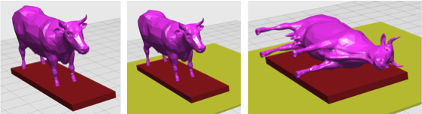

The second type of connector type we use is a bar. A bar is modeled as a thick cylinder. One side of the cylinder intersects with the object and the other side intersects with the canvas. Optionally, a base can be added to the canvas end. This base makes it possible to print the object and the canvas separately and use adhesives them together. Multiple bars can be used to make the structure more study.

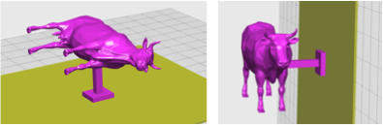

## Movables

We define a *movable* as a set of components that be added to or integrated with canvases and tactile objects to make them movable by a child.

### Hinge

A hinge movable is designed to provide a tangible experience equivalent to that of "opening" a door or "flipping" a lid. Many hinge models can be found on Thingiverse. We tested several and decided to model ours after [X] because (1) it is printable without support material, (2) it fits our canvas models quite well, and (3) it is parametric; several attributes such as widths and heights are adjustable. We also made a number of enhancements to the model to make "print-and-assemble" possible. First, we add a clamp like structure to make it easy to attach an existing tactile picture page to it. Second, we create a trough-like component that can be glued to a canvas as a holder of the hinge.

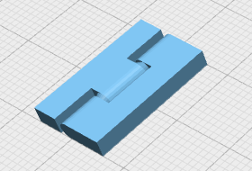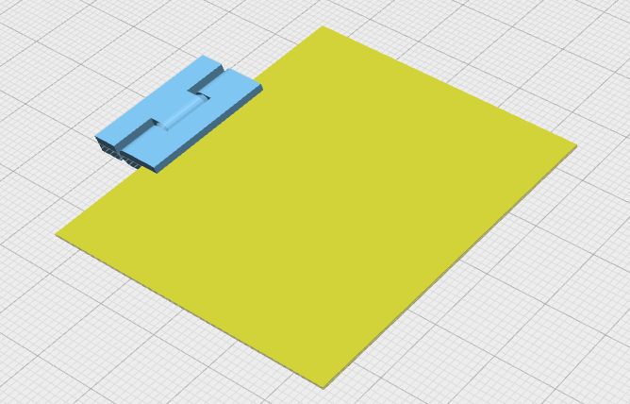

### Track

A track movable is designed to enable a tactile object to be moved by a child along the direction of the track, for instance, dragging a rocket from one side of a picture to the other side. We model the a track after a typical "drapery track" which consists of a long horizontal of a track using a upside down T A track movable is modeled as of a track with a grove and a platform

### 

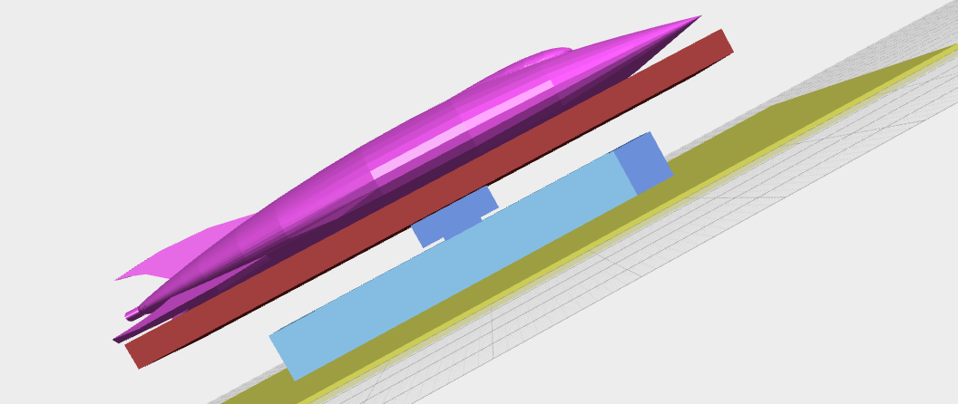

### Spinner

A spinner movable enables a tactile object to be spin, turned, or rotated by a child, for instance, turning a wheel of a vehicle. For VI children, there are plenty of physical analogies in toys such as cars and trains. We model it using two components. One component is the base with a pin. The other is a wheel with a flat top for a tactile picture to connect to. They can be printed separately and put together. A spinner component set can be applied to swinging by restricting the range of angular movement.

### 

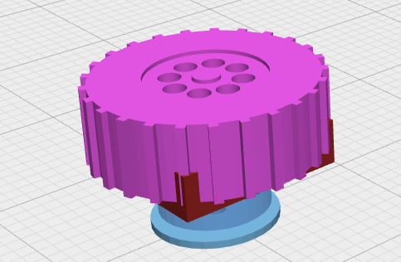

### Slider

A slider movable enables a child to slide a canvas to the side, for instance, to reveal the content underneath the canvas. In comparison, a track movable is mainly for moving a single object. The physical analogy a child can relate to would be a French door. A slider has two tracks on along the two sides parallel to the direction of movement.

### Lift

A lift component set enables a child to pull a tactile object upward (away from the canvas) or push it lower (toward the canvas). We model a lift component using the physical analogy of a straw going through a tight hole on a lid. A child can relate to the experience of pulling a straw up and down. The tightness of the hole provides friction to keep the straw from falling down. It has three parts. A rod to acts like a straw, a pedestal for holding an object, a base with a tight hole for the rod to go through and for securing the object to a canvas, and a stopper to prevent a child from pulling the object out.

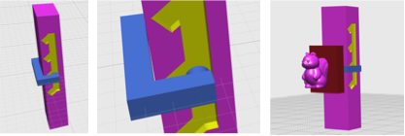

## Support

We need pieces to provide structural soundness and sturdiness.

### Wall

A wall can be placed on a canvas to (1) support another canvas from underneath, or (2) surround an object to hide it from a child.

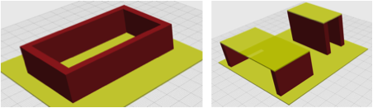

### Column

A column's sole purpose is to support another canvas above.

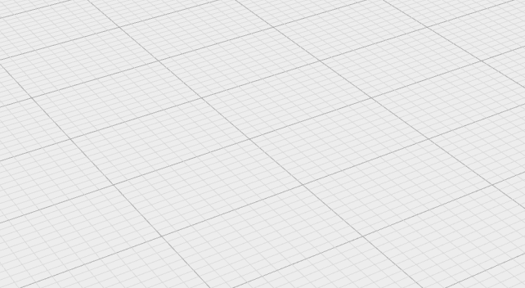

### Platform

A platform can be added to an area on a canvas to raise the area upward from the ground.

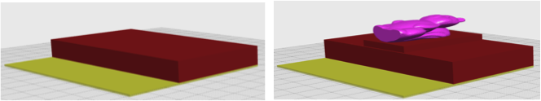

### Slope

A slope is a special kind of a platform whose top surface has an angle.

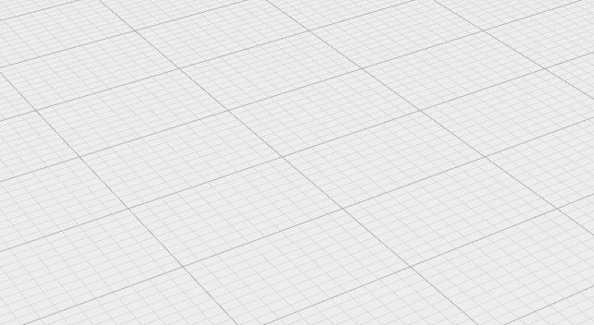

### Cutout

A cutout's purpose is to define an opening on a canvas. It allows a child to see or feel through the opening and discover what is behind the canvas. The opening must be big enough for a child's finger to go through.

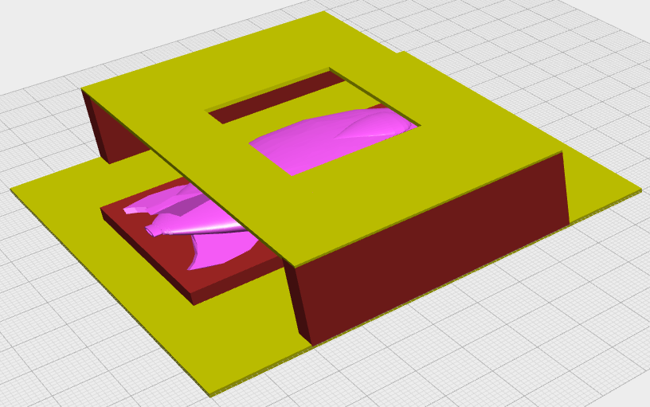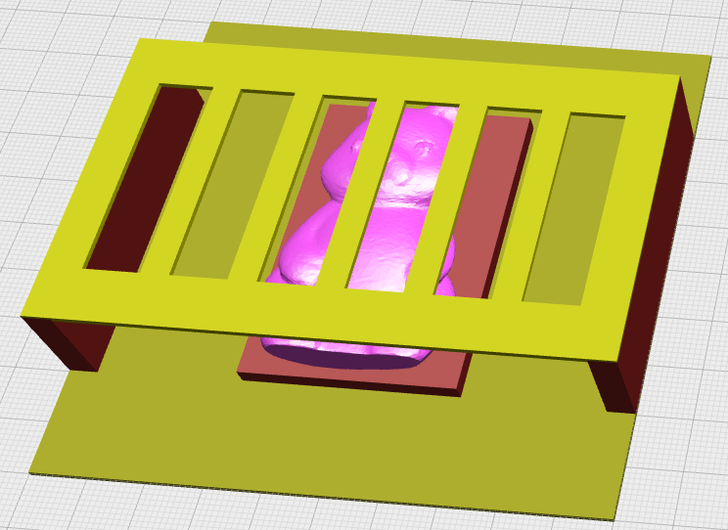

# Concepts

Our goal in terms of promoting emergent literacy is to enable the creation of a new class of tactile pictures that are \_movable\_ in order to convey concepts that would be hard to do using traditional static tactile pictures.

### Inside/Outside

This example conveys the concept that a squirrel is inside a tree. It is achieved using two tactile objects (squirrel, tree), two canvases (top, bottom), two walls, and a hinge for opening the top canvas. A child can "open" the tree to examine inside and discover a squirrel.

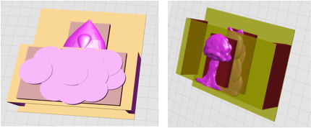

### Up/Down, Left/Right

This example conveys the concept that a rocket goes up and down. It is achieved using a tactile object (rocket), a canvas, and a track.



### Higher/Lower

This example conveys the concept that a rabbit jumps higher than a frog. A child can pull a rabbit and a frog up from the ground and discover that the rabbit can be pulled higher. It is achieved using two raiser movables at different height specifications, each of which holds an object.



### Front/Behind

This example conveys the concept that a gorilla is behind a door. A child can slide the door and discover the gorilla behind. It is achieved using a slider, two canvases (one for the gorilla and one for the door).



### Motion

The example conveys the concept that the wheel of a car spins. It is achieved using a spinner, a tactile object attached to the spinner, a raised line model of a car, and a canvas holding everything.



# Design Language

Our first contribution is the design of a suite of reusable 3D printable components that can be composed into a variety of movable tactile pictures. We share our models as STL files. One can import them into a design space of a 3D modeling software. She can use a mouse and a keyboard to move, scale, and rotate these models to form a coherent picture. But there are two issues. First, the composition process is manual and laborious. Second, it requires considerable skills to operate the GUI of a 3D modeling software to perform the composition task.

We argue that the task of designing a page of movable tactile pictures is similar to the task of designing web pages. The two pillars of web design is HTML for content/structure and CSS for style. We take inspiration from this.

We propose a design language for specifying a movable tactile picture based on XML and CSS. A designer can define the content and structure of a tactile picture in an XML file. She can also specify the style attributes of each element in a style sheet (CSS). Furthermore, we develop a system that \_compile\_ the specification into a 3D model of a movable tactile picture. This 3D model can be either 3D printed as a whole (using a high-end 3D printer) or as individual, easy-to-assemble parts (using a commodity 3D printer).

We do not claim that XML/CSS is the level of abstraction accessible to \_everyone\_. What we do claim that this level of abstraction would enable a much larger user population than skilled 3D modelers to contribute to the design of 3D tactile pictures. Moreover, our system can pave a way for others to build WYSIWYG editor on top to further lower the barrier.



## Hello Squirrel

1. **<canvas>**
2. **<object** src="squirrel.stl"**>**
3. **</canvas>**

## Complex Example

We present a complex example to highlight the key features of our design language.

1. **<canvas>**
2. **<track** length="30" direction="north" slope="20"**>**
3. **<spinner>**
4. **<object** src="rocket.stl" x="10" y="10"**/>**
5. **</spinner>**
6. **</track>**
7. **<door** orientation=south y="50%" height="50%"**>**
8. **<canvas** width="100%" height="100%"**>**
9. **<object** src="cloud.stl"**/>**
10. **</canvas>**
11. **</door>**
12. **</canvas>**

## Object Naming

Our design language allows the naming of tactile objects. Names increase readability. They can be defined in a centralized location separate from the main design file. They can be reused across multiple design files. It would be easier to switch to another 3D file to represent an object, for example, an alternative STL for a rocket. Here is an example of object naming specification:

1. **<objects>**
2. **<object>**
3. **<name>**cloud**</name>**
4. **<source>**cloud.stl**</source>**
5. **</object>**
6. **<object>**
7. **<name>**rocket**</name>**
8. **<source>**rocket.stl**</source>**
9. **<connector-type>**pedestal**</connector-type>**
10. **</object>**
11. **</objects>**

Then, in the design specification, we can write

1. **<canvas>**
2. **<cloud/>**
3. **<rocket/>**
4. **</canvas>**

Then, to use cloude1.stl instead, we only need to modify objects.xml, instead of going back to every page to modify the file reference.

## Style

To separate style attributes from content and structure.

1. #myPage {**width**:50, **height**:50}
2. .sideDoor{**width**:100%, **height**:100%}
3. .myCutout{**width**:50%, **align**:center;}

Then, we can use class/id styles in the design file.

1. **<canvas** id="myPage"**>**
2. **<gorrila>**
3. **<door** class="col-4" direction="left"**>**
4. **<canvas** class="sideDoor"**>**
5. **<cutout** class="myCutout"**/>**
6. **</canvas>**
7. **</door>**
8. **<door** class="col-6" direction="right"**>**
9. **<canvas** class="sideDoor"**>**
10. **<cutout** class="myCutout"**/>**
11. **</cavnas>**
12. **</door>**
13. **</canvas>**

## 

## Implementation

To implement the functionality to generate a model from a specification, we need to redesign all our models as programs that we can invoke with different parameters. Our initial choice was OpenSCAD, widely used open source software for this very purpose. OpenSCAD allows us to design parametric models using \_modules\_. However, after working with OpenSCAD for a while, we found it lacks many important features of a "real" programming language to do what we want. We started to look for an alternative and found a better solution in OpenJSCAD (the extra J stands for Javascript).

- Use object-oriented programming. Each component model is an object with methods and attributes.

- Use existing Javascript libraries for parsing XML files and stylesheets.

(design, stylesheet) —> xml parser, stylesheet parser —> json —>

# Evaluation

## Printability of 3D Printers

The printability of the moving parts is one of important part to consider. Currenlty, many different kinds of 3D printer are used in general. Also, parents and teachers of customize size and kinds of moving primitives, we tested printability of moving parts. Below table shows differences between four types of 3D printer.

|  |  |  |  |  |
| --- | --- | --- | --- | --- |
|  | Object30 | MakerBot (5th Gen) | LulzBot TAZ | Creator\* |
| Machine Price | High | Mid | Mid | Low |
| Material cost | High | Low | Low | Low |
| Printing speed | Slow | Mid\*\* | Mid\*\* | Fast |
| Printing size | Big | Mid-Small | Mid | Small |
| Quality | High | Low | Mid | Mid |
| Supporting | Separate material | Same material with printing part | | |
| Post Processing | Water soluble | Risk on breaking part  while tearing off supporting | | |
| Printability | Print as an entire piece | Print as separate parts and layer  Post-assembly needed | | |

*\*Creator is tested by retail 3D printing store, where 3D prints file given by customer and deliver by post*

*\*\*Printing speed can be adjusted by changing printing quality*

The majority of desktop 3D printer for home does not provide a supporting material that fills and supports the gap between bottom layer of tactile picture and the second layer of moving part and/or another tactile picture. For generally used mid-end 3D printers, such as Makerbot Replicator, we modified the moving parts’ design for easy printing. The new version of 3D movable parts lay flat on printing base, without after processing of cleaning up scaffoldings, users print the first and second layer as separated pieces and fabricate like LEGO pieces.

## Dear Zoo

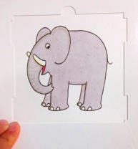 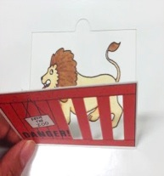 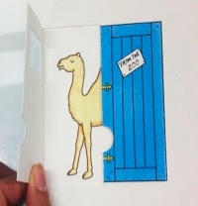 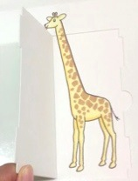 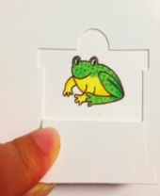 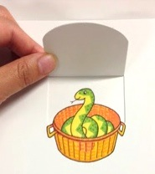 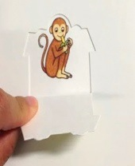 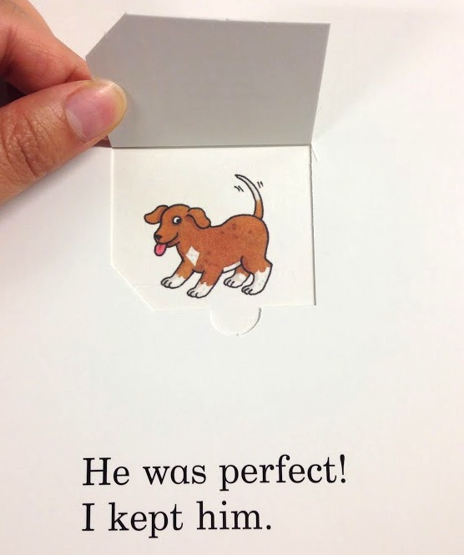

**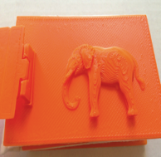 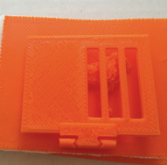** 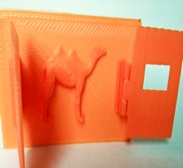 **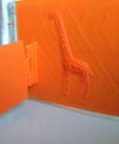 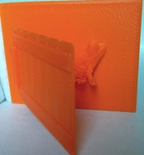 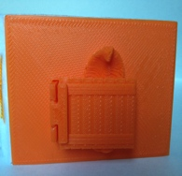 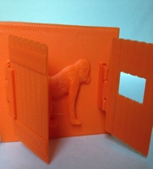 `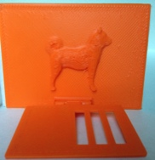**

We evaluated our approach by transcribing all the pages of the book, Dear Zoo, into movable tactile pictures. This was a book chosen by our workshop participants during our formative studies. The story is about animals children can typically see in a zoo and fences in front of each animal for children to “open” the fence and “discover” the animal. This book serves as a good test bed for the model synthesis function we developed. Figure 5 shows the models generated by our OpenSCAD program for eight of the pages in the book. These pages share a common moving primitive (i.e., hinge) and effect template (i.e., appear). But they vary in the object model (e.g., elephant, horse) that populates the template. Also, each page is further customized differently in terms of the orientation of the hinge (horizontal vs. vertical), coverage (half vs. full), and configuration (one-side vs. split). The animal objects were imported from Thingiverse. Not only that, four different types of door applies “cutout” effect to enhance more touch experiences over the flow of a story. Below figure shows the four different types of cage. This example demonstrates that the tactile components we have created can indeed be reused and applied to synthesize a wide range of movable pictures.

|  |  |  |  |
| --- | --- | --- | --- |
| Macintosh HD:Users:qubick:Pictures:iPhoto 라이브러리.photolibrary:Previews:2014:09:19:20140919-181356:QFQc2n3TRlCqNGZ0mxa3Pw:IMG_6545.jpg | Macintosh HD:Users:qubick:Pictures:iPhoto 라이브러리.photolibrary:Previews:2014:09:19:20140919-181420:BXd972VtREWqEHcNnuTg0Q:IMG_6546.jpg | Macintosh HD:Users:qubick:Pictures:iPhoto 라이브러리.photolibrary:Previews:2014:09:19:20140919-181449:Yz5btKc2Slu7omMs2Kpd3w:IMG_6547.jpg | Macintosh HD:Users:qubick:Pictures:iPhoto 라이브러리.photolibrary:Previews:2014:09:19:20140919-181449:yB+UZeTpTn65j1m%vYb6CQ:IMG_6548.jpg |

Figure XX. Four door types with cutout effect. Differentiation enables children evolve from thinking simple shape of the door, to different moving direction and unique attributes (a) a huge simple door with wood laminate texture (b) door with ribs (c) door with window that lead children touch inside through (d) lower door that shows scrap of animal before opening it

## When I’m Big

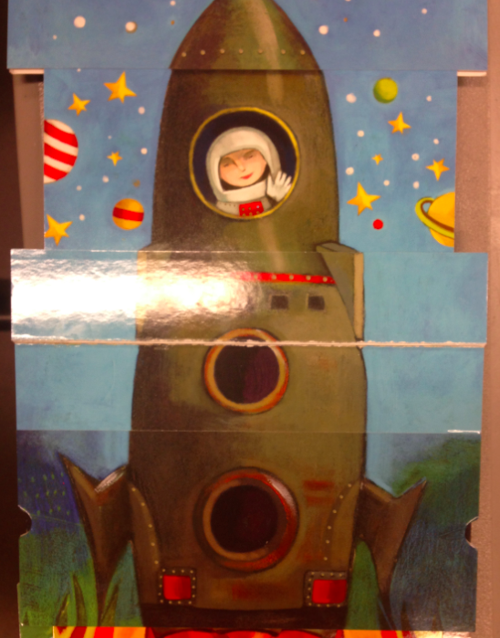 (second pic) 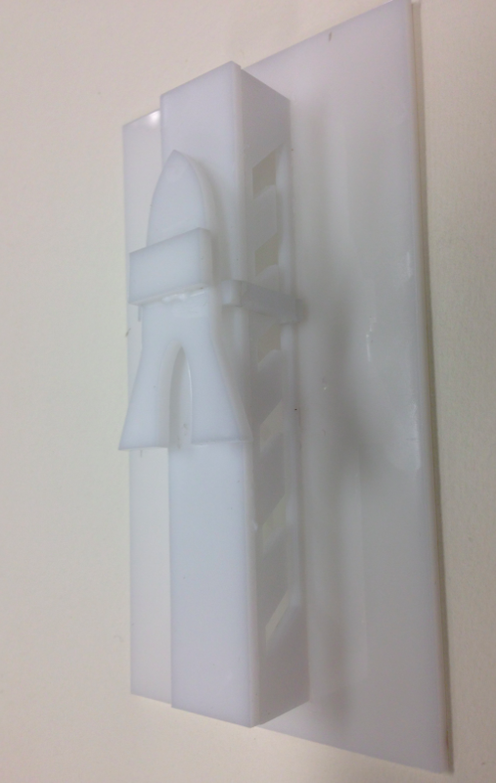

The rocket drawn in *When I’m Big* book moves up by pushing the pulley, which is a part of picture up. The Lift effect can efficiently express the skyrocketing movements of the object. The rocket is moved up step by step

## Hop, Skip, and Jump, Maisy

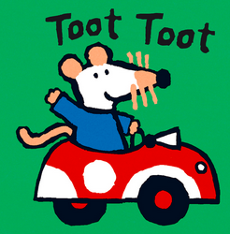 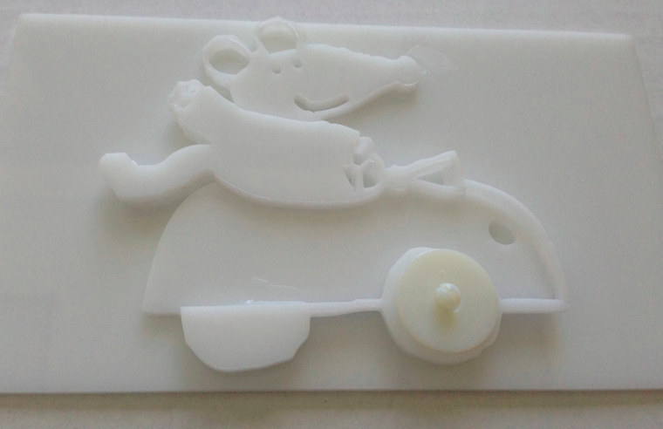

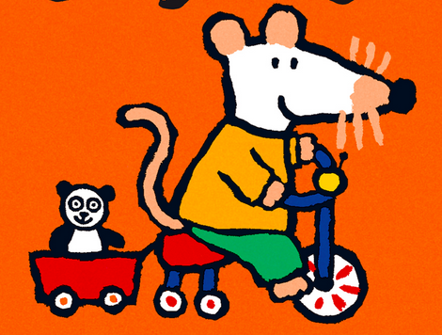 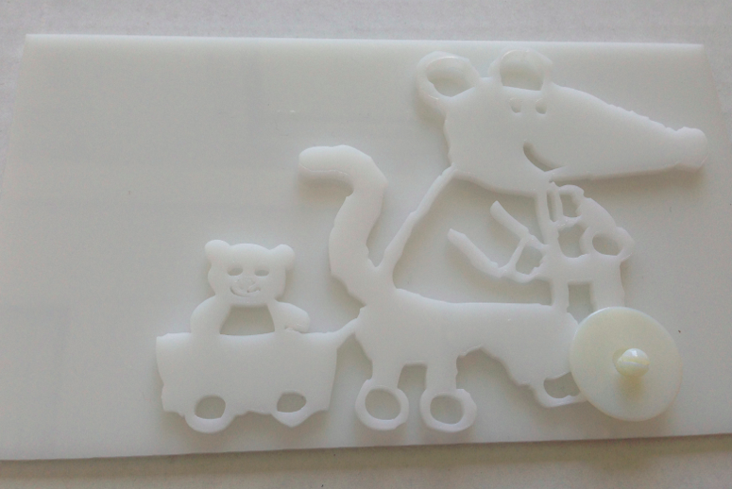

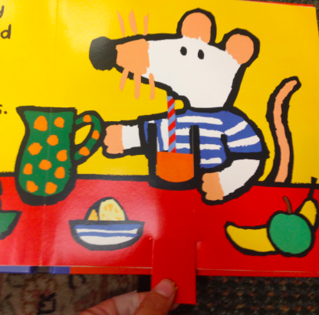 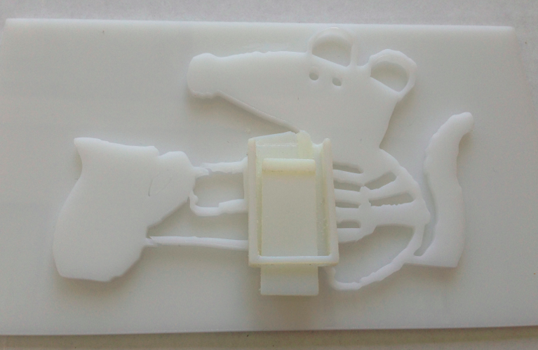

## The daily life story of Maisy mouse includes many kinds of interactive mobility. For example, the wheel of car (a) and bike (b) are rolling, by being replaced a part with spinner. Also, the picture of Maisy’s drinking juice (c) represents the rest amount of juice in the glass. Visually impaired children can pull down the pulley, and touch the top of it with the other hand, and feel how the relative height of the juice decrease, the situation they will never touch directly in real life.

## All the Fun of the Fair

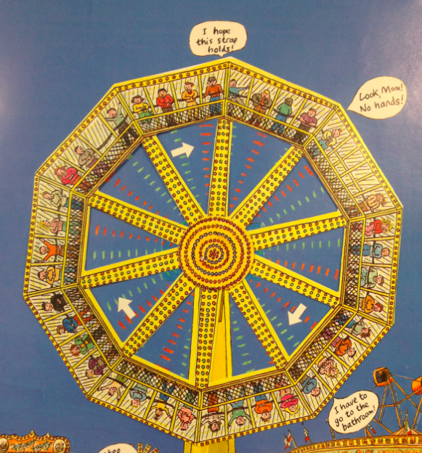 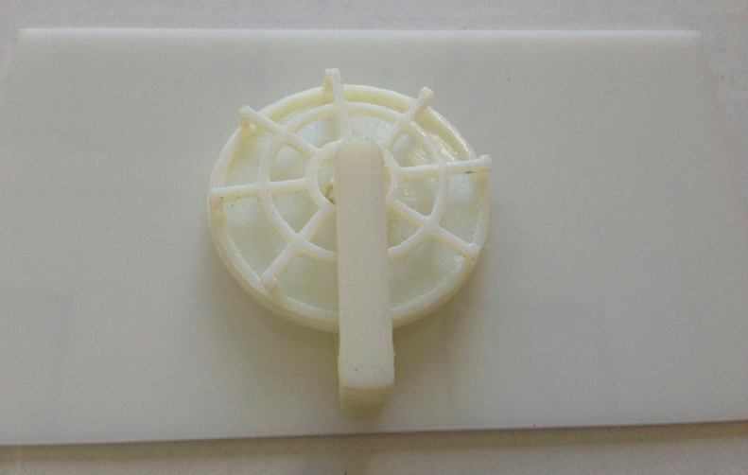

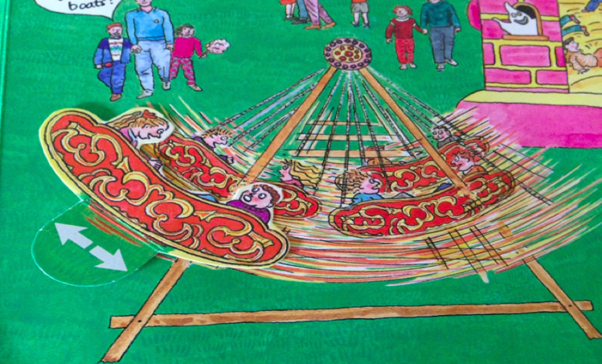 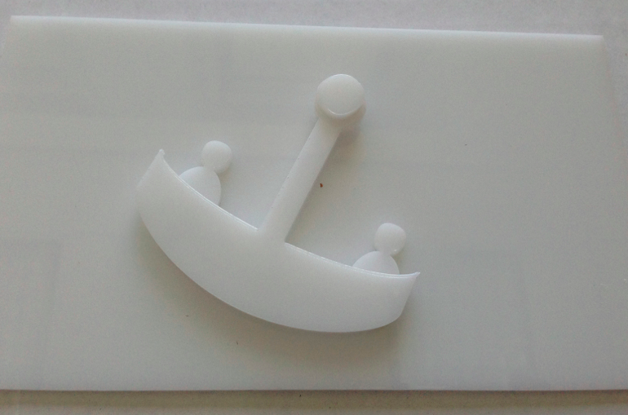

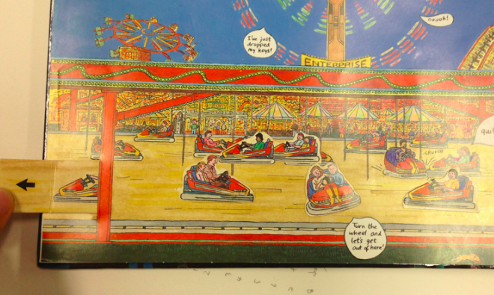 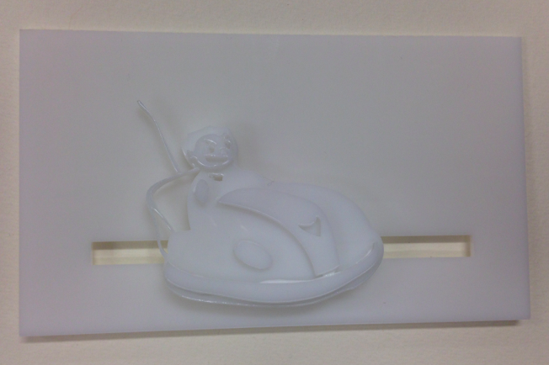

*All the Fun of Fair* book also presents different types and size of primitives. For example, the flap is used to expose a ghost in a haunted house, the pulley is used to drag a slide riding people. In our example, a rolling giant wheel (a) is represented with a spinner, which is combined with frame of wheel as tactile figure. The biking roller coaster (b) is turned into a swing with shapes of human. The track primitive is adapted to a bumper car (c) play ground, so that children can move around a boy riding a bumper car left and right.

## Alphabet

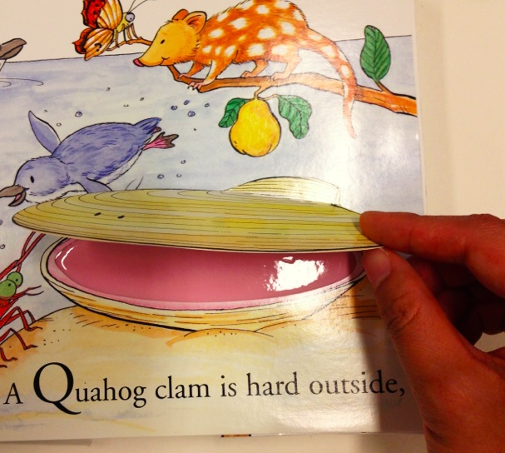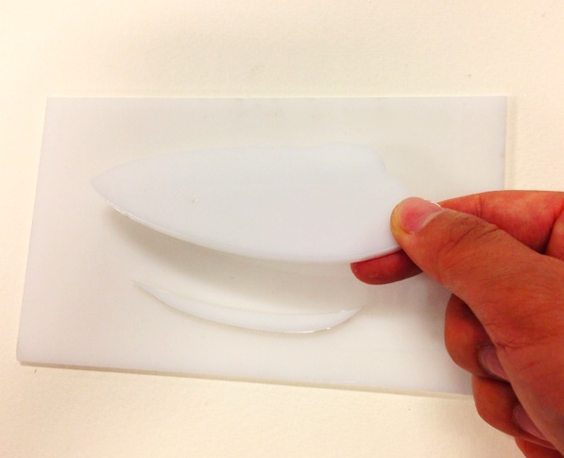

## Alphabet written by XX introduces examples of animal that starts with each alphabet character. Visually impaired children will open the top of a clam that covers inside flesh, by lifting the flap.

## What’s the opposite?

## Macintosh HD:Users:qubick:Desktop:Screen Shot 2014-09-18 at 8.49.10 PM.png

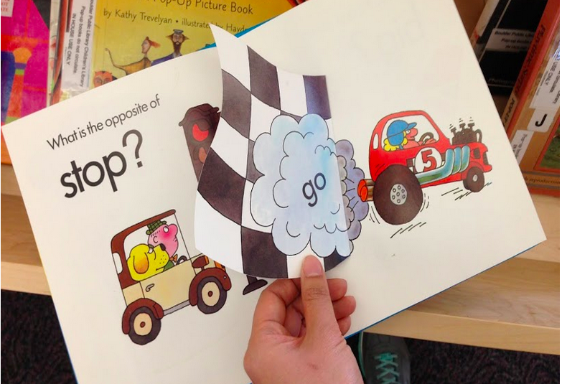 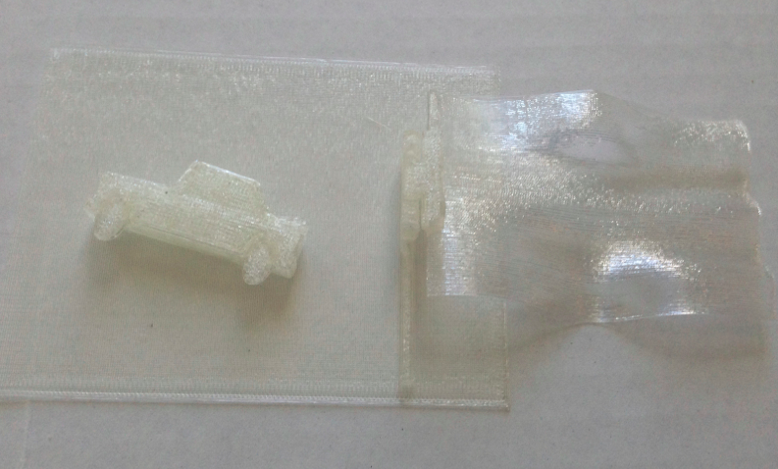

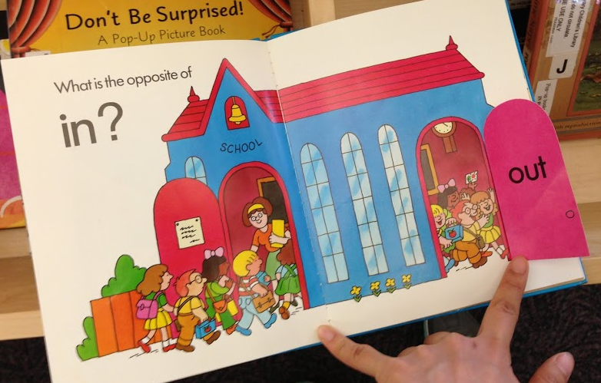 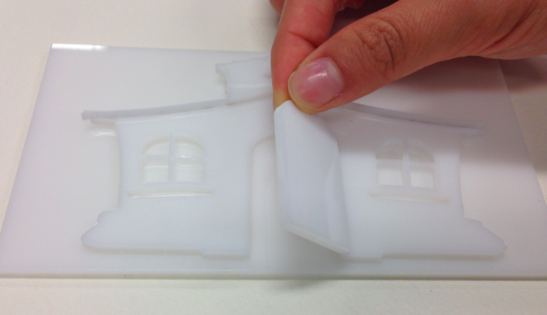

The author of *What’s the Opposite?* book introduces spatial concepts in contrast, lifting the flap and uncover something behind it. The rocket under the cloud (a), a moving car behind the flag (b), and coming out children behind the door (c) are applications of it. Flapping parts of each page are combined with a hinge that enables objects to be turned over.

## Gossie Plays Hide and Seek

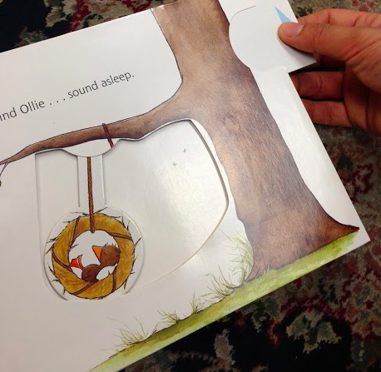 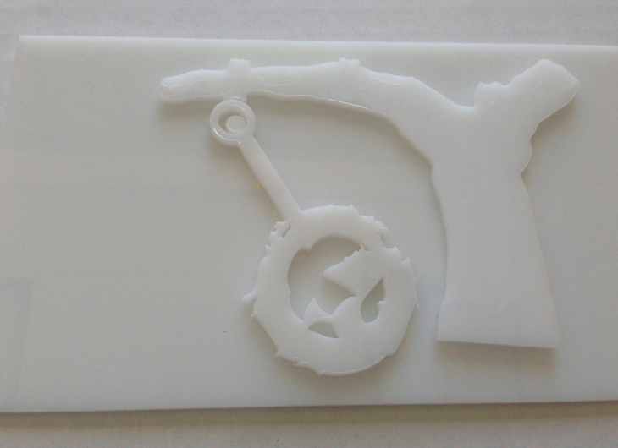

*Gossie Plays Hide and Seek* also implements a set of examples of push and pull with pulley, uncovering hidden object by lifting the flap. One interesting feature is that Gossie bird is getting on the swing that hang over the tree. Connected with tactile pictures of tree and bird, this feature will more specifically introduce the concept of tree swing to blind children.

## Experts Feedback

## We interviewed experts who are related into creating and publishing tactile books to solicit their perspectives and feedback. Our purpose includes to test tactility and readability of tactile book by interviewing (1) a blind adult (2) braille book publishers from National Braille Press, to find usability of the movable tactile book as class material for blind children by interviewing (3) 4 teachers of preschool for blind children, (4) a teacher of school for deaf children. Also, we investigated the printability and accessibility of movable tactile books from parents, by interviewing (5) librarians of public library, who designs and associate family activities.

## Active Reading Motivator

Compared to our previous 3D printed stationary book, which is still tactile but not interactive, movable pieces help children learn mobility, by being engaged in the book reading actively. Usually, children with visual impairments are in passive reading situation. They listen parents and teachers reading, but giving control to children with pictures of what they are doing engage them to deeply dive into the story. Teachers of the blind children and deaf students said having them can manipulate is a huge motivator. Even for sighted kids, fidgeting parts of pictures lead them to pay attention what they are doing, being engaged in storytelling, [Cassell] makes them to reiterate moving, makes them think of this mobility always.

**Literacy Evolution by Variations of Interaction**

Teachers and the artist liked the four different variations of door of *Dear Zoo,* because they believe this teaches distinct concept from same activity. Children will learn how the cage looks like from the first page of huge but simple container hides elephant, more concentrate on the smaller door to feel how it is different from the previous plain shape. And finally, children finalize developing their emergent literacy on the “door” and “open” from a pair of doors that are opened in two directions or flapping down. It will present possible versatility of door shape and opening action. Not only that, by touching inside animal via ribs of the cage and through the window, they can be asked to guess what is the salient feature of the animal. This can be the trigger of remembering specific animal.

**Fun Activity for Post Assembly**

It is essential for parents and teachers to do after finishing tasks, including fabricating movable blocks. Family activity designer from public library and teachers of blind children comment doing special tasks make the educational material special, and unique for their children. They suggest to add any “fun” to printing 3D printed movable tactile pictures. Since our movable picture is printed several layers in flat in order to avoid printing scaffolding which takes a lot of printing time, cost, and risk of breaking parts during after cleaning process. The reason why people buy special LEGO set is, for example, not only getting the final piece of toy, mainly for enjoying fabrication activity together, understanding a process, and get an unique efforts-putting-toy.

## Design Considerations

From the discussion, we set a list of design consideration for next creation of movable tactile pieces. Some consideration takes trades off each other, so we should concentrate on the specific purpose of tactile transcribing.

• **Iteration of Movements:** Likewise the door example, iterating a simple interaction with various type and size helps children to build firm concept of literacy. Tactile book publishers from National Braille Press recommended us to transcribe “Noah’s Ark” for next creation, since it introduce a pair of animal per page with different posture and perspective, and finally composite all animals at the end to reveal relative sizes between different animal, and to present spatial concept relying on animals position, such as sky where birds fly, the ground where snake lives.

• **Age of child:** Development level of literacy of every child is huge rely on the age of child. For those who already know how mouse looks like, the tactile picture does need to present very refined and detail feature of mouse including four legs but relatively fat thigh. However, 0 – 2age year old kid who never heard or touch the mouse, it is more important to emphasize long curvy tail and big ears, even though they are exaggerated than the real.

• **Key idea to convey:** The relative size of object in one page and simplicity of the abstraction are controversial point we need to be careful. When the book is targeting young kid and we want to introduce the shape of the object of animal, experts says we do not need to consider the size at that moment. For example, elephant from the first page of *Noah’s Ark* can be same size with the second page of duck, since two pages brings concept of shape, not convey relative sizes. Since the idea that the last page of the book conveys is the size, then differentiation of sizes compared to others will be the most important part.

• **Simplicity:** The level of simplicity follows two previous design consideration, age and key idea. Good tactile picture highlights only one concept per object. If too much detail is incorporated in one page, it is a lot of distraction. In order to keep children pay attention to the picture, it need to focus on salient feature of the moving object interpreted in 3D tactile picture.

• **Co-reading Context**: Even sighted kid is spoken not only story but also a ton of relevant words by their parents while co-reading children book to enhance book reading experiences [Alborzi] [Beukelman] Transcribing exact picture is important task, but make the context of the page to induce questioning and answering will form a strong intellectual curiosity for children. For example, a window of the door leads children touch inside first before opening up, a bird over tree swing bring out interaction between children and parents, building substantial bonds that help parents understand their children’s interests and needs.

• **Textures and Colors:** Although colors are not representative for each object, it is still important to embed colors for children with low vision. It does not mean the giraffe has ocher body and brown spots, it is enough to deploy one solid color for page background, one solid color for an entire animal body, and one another for door. Instead, textures on raised dots over giraffe body will replace real color dissimilarities. In terms of substitution of colors, texture of laminated woods on the cage is a good tactile representation.

**Future Suggestion**

Experts remakred few comments on our next iteration. The book need to be printed in real book size. Grabbing two small pieces makes the page more fragile, as well as enough big size of 3D printed objects more legible. They always hope to involve soft textures using fabrics and yarn, and so on. Sythesizing different printing technics, or even hands on fabrication of various materials will enrich children’s understading natural attributes of real life objects. Also, pictures are always support children to develop literacy, tactile pictures will be a huge chance to learn braille inversely. By putting simple words beside the tactile pictures and movements, children with visual impairements will remember braille efficiently with the memory of touch experience. Regarding textures, we were suggested to Atheton fisishing for 3D printed pages. Due to the mechanism of how 3D printer prints models, stranded layer of molten palstic make thread layers over objects printed on the page. However, this orthogonal layers confuses children’s touch experiences, so moothing surfaces will make more chance to produce secure and solid touch experiene for children.

# References

1. Lipson, H. & Kurman, M., (2013). Fabricated: The New World of 3D Printing, Wisely

2. Philippe C., (2009). The Typhlo & Tactus Guide to Children’s Book with tactile illustrations, Les Doigts Qui Revent

3. Suzette, W., (2013). Guide to Designing Tactile Illustrations for Children’s Books, American Printing House for the Blind

4. Bus, A. G., (2003). Joint Caregiver-Child Storybook Reading: A Route to Literacy Development, Handbook of Early Literacy Research., Vol.1, ISBN/UPC 9781572306530, The Guilford Press

5. Abigale, 3D Printed Tactile Picture Books for Children with Visual Impairments: A Design Probe

6. Kim, J., Stangl, A., Eisenberg, A., & Yeh, T. (2014). Tactile Picture Books for Young Children with Visual Impairment, Works-in-Progress, TEI’14

7. Brown, C., Hurst, A., VizTouch: Automatically Generated Tactile Visualizations of Coordinate Spaces

8. MakerBot Thingiverse <http://thingiverse.com>

9. Google Sketchup 3D warehouse <https://3dwarehouse.com>

# 10. [McGookin, D.](http://eprints.gla.ac.uk/view/author/4038.html), Robertson, E., and [Brewster, S.A.](http://eprints.gla.ac.uk/view/author/11463.html) (2010) *Clutching at straws: using tangible interaction to provide non-visual access to graphs.* In: Proceedings of ACM CHI 2010, 10-15 Apr 2010, Atlanta, GA, USA.

11. Yahoo japan, voice command over 3D printing

12. Hengeveld B., Hummels C., Overbeeke K. Tangibles for Toddlers Learning Language. Proc. Tangible and Embedded Interaction (TEI'09), 161-168, ACM Press, 2009

13. Garzotto, f., Bordogna, M., Paper-based Multimedia Interaction as Learning Tool for Disabled Children

14. Marshall P. Do tangible interfaces enhance learning? Proc. Tangible and Embedded Interaction 2007 (TEI’07). ACM Press (2007), 163 - 170

15. Alborzi, H., et al. Designing StoryRooms: Interactive Storytelling Spaces for Children. Proc. DIS '00. 2000, ACM, 2000, 95-104

16. Beukelman, D., & Mirenda, P. Augmentative and alternative communication: Supporting children and adults with complex communication needs. Paul H.Brookes, Baltimore, 2005.

17. Budd J., Madej K., Stephens-WellsJ., Jong , J., Katzur E., Mulligan L. PageCraft: learning in context a tangible interactive storytelling platform to support early narrative development for young children. Proc. IDC 2007, ACM Press, 97-100

18. Cassell J, Ryokai K, Making Space for Voice: Technologies to Support Children’s Fantasy and Storytelling, Personal and Ubiquitous Computing, 5, 3, 169-190, August 2001

19, Fontijn, W., and Mendels, P. StoryToy the Interactive Storytelling Toy. in Proc. Pervasive Computing, 2005